**Solving Equations-Questions**

Key Stage 3: 2003 Paper 1 Level 3-5

1.

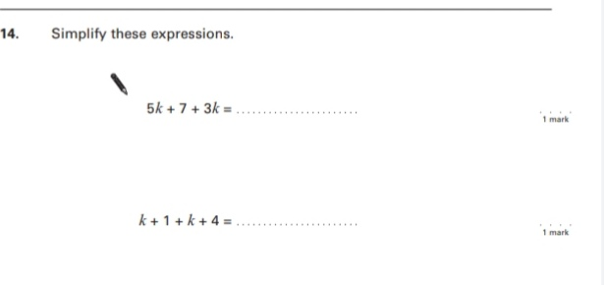

2.

Key Stage 3:2003 Paper 2 Level 3-5

3.

Key Stage 3: 2003 Paper 1 Level 4-6

4.

5.

Key Stage 3: 2003 Paper 2 Level 4-6

6.

Key Stage 3: 2004 Paper 1 Level 3-5

7.

Key Stage 3: 2004 Paper 2 Level 3-5

8.

9.

Key Stage 3: 2004 Paper 1 Level 4-6

10.

11.

12.

Key Stage 3: 2004 Paper 2 Level 4-6

13.

14.

Key Stage 3: 2005 Paper 1 Level 3-5

15.

16.

Key Stage 3: 2005 Paper 1 Level 4-6

17.

18.

19.

Key Stage 3: 2005 Paper 2 Level 4-6

20.

Key Stage 3: 2006 Paper 1 Level 3-5

21.

Key Stage 3: 2006 Paper 2 Level 3-5

22.

Key Stage 3: 2006 Paper 1 Level 4-6

23.

24.

25.

Key Stage 3: 2006 Paper 2 Level 4-6

26.

27.

Key Stage 3: 2007 Paper 1 Level 3-5

28.

29.

Key Stage 3: 2007 Paper 2 Level 3-5

30.

31.

Key Stage 3: 2007 Paper 1 Level 4-6

32.

33.

34.

Key Stage 3: 2007 Paper 2 Level 4-6

35.

36.

37.

38.

39.

Key Stage 3: 2008 Paper 1 Level 3-5

40.

41.

Key Stage 3: 2008 Paper 2 Level 3-5

42.

Key Stage 3: 2008 Paper 1 Level 4-6

43.

44.

45.

Key Stage 3: 2008 Paper 2 Level 4-6

46.

47.

48.

Key Stage 3: 2009 Paper 1 Level 3-5

49.

Key Stage 3: 2009 Paper 2 Level 3-5

50.

51.

Key Stage 3: 2009 Paper 1 Level 4-6

52.

53.

54.

55.

Key Stage 3: 2009 Paper 2 Level 4-6

56.

57.

Key Stage 3: 2010 Paper 1 Level 3-5

58.

59.

Key Stage 3: 2010 Paper 1 Level 4-6

60.

61.

62.

63.

64.

Key Stage 3: 2010 Paper 2 Level 4-6

65.

Key Stage 3: 2011 Paper 1 Level 4-6

66.

67.

Key Stage 3: 2011 Paper 2 Level 4-6

68.

69.

